Site Review 2

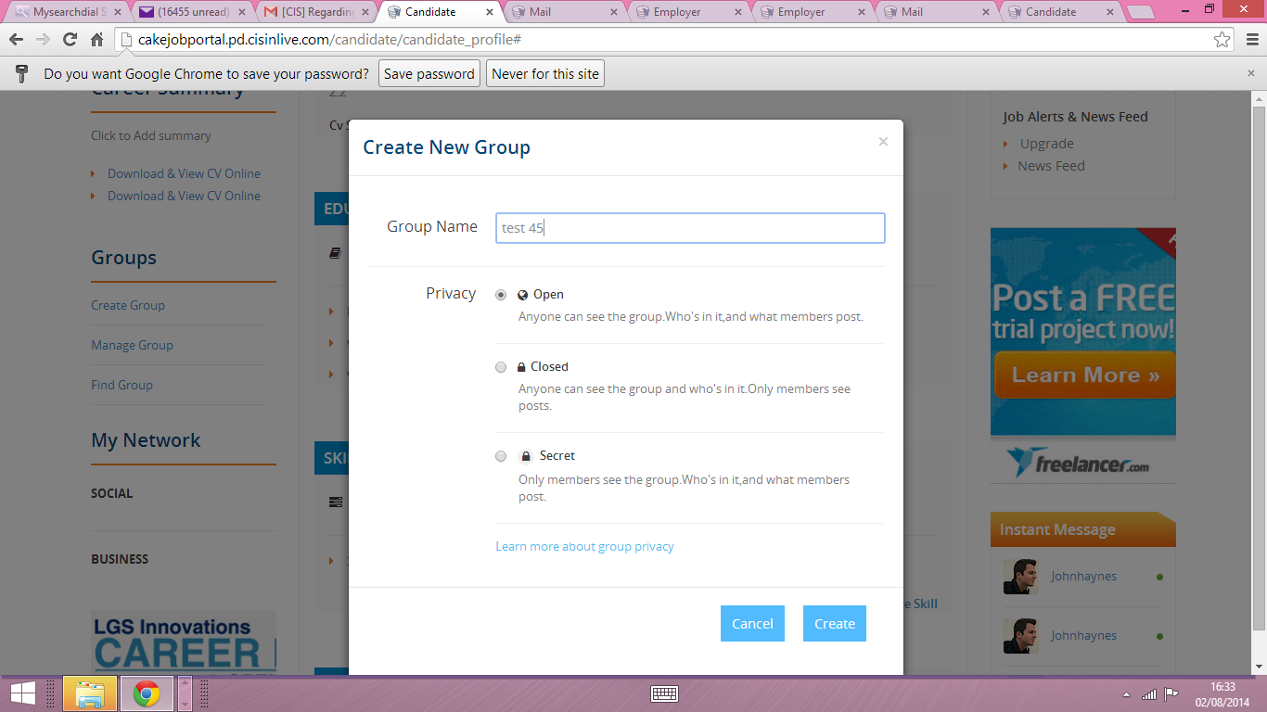
The create group- once you select open for the privacy it moves to closed when you click on create- should this be happening just before you move to the new group you have created.
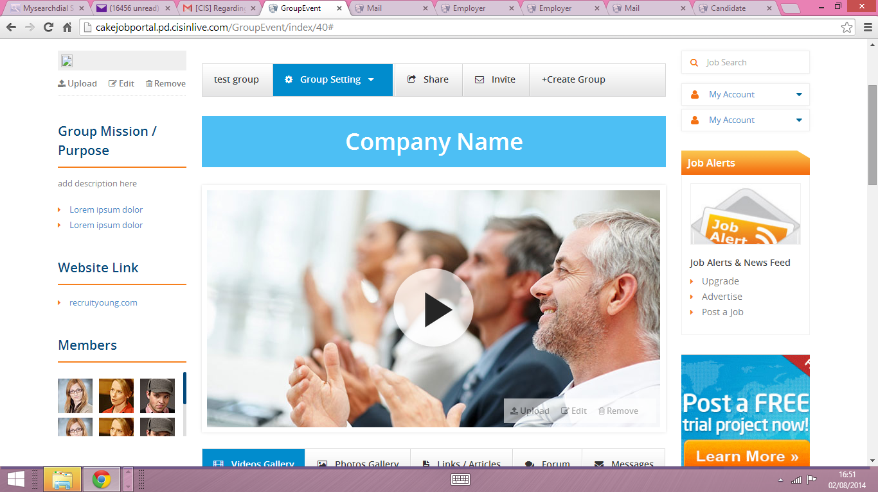
- I am unable to edit the text under Group Mission /Purpose, also there are two links under the add description that I do understand the purpose of them.
- I am still unable to edit the website URL under the website link, this should be for the group user’s website link.
- 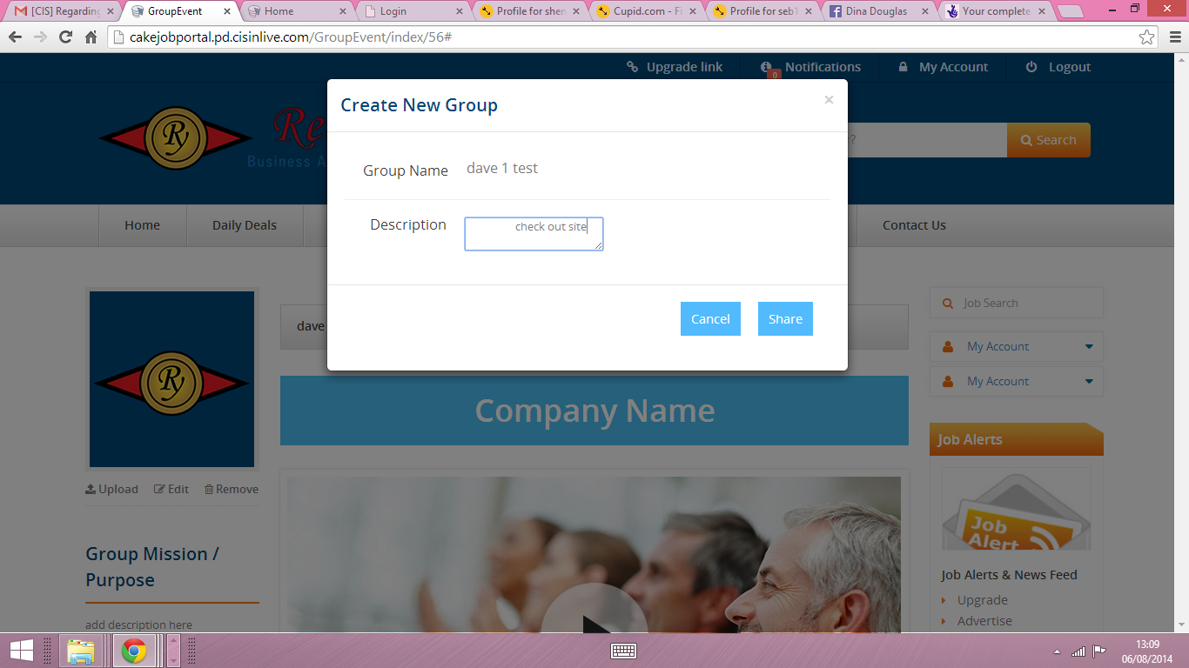
- The group share tab when you click on it says create new group – it should say something like SHARE THIS NEW GROUP.
- The group setting link needs to be able to select either private, public and I guess secret too as a drop down feature at the moment it only shows the options but you can’t select any. Please leave the tab as Group setting rather than open.
- The banner that says company name should be linked to the name given to the group, therefore it should be the group’s name there.
- The upload feature do not work for photo upload only video it should be for both options. 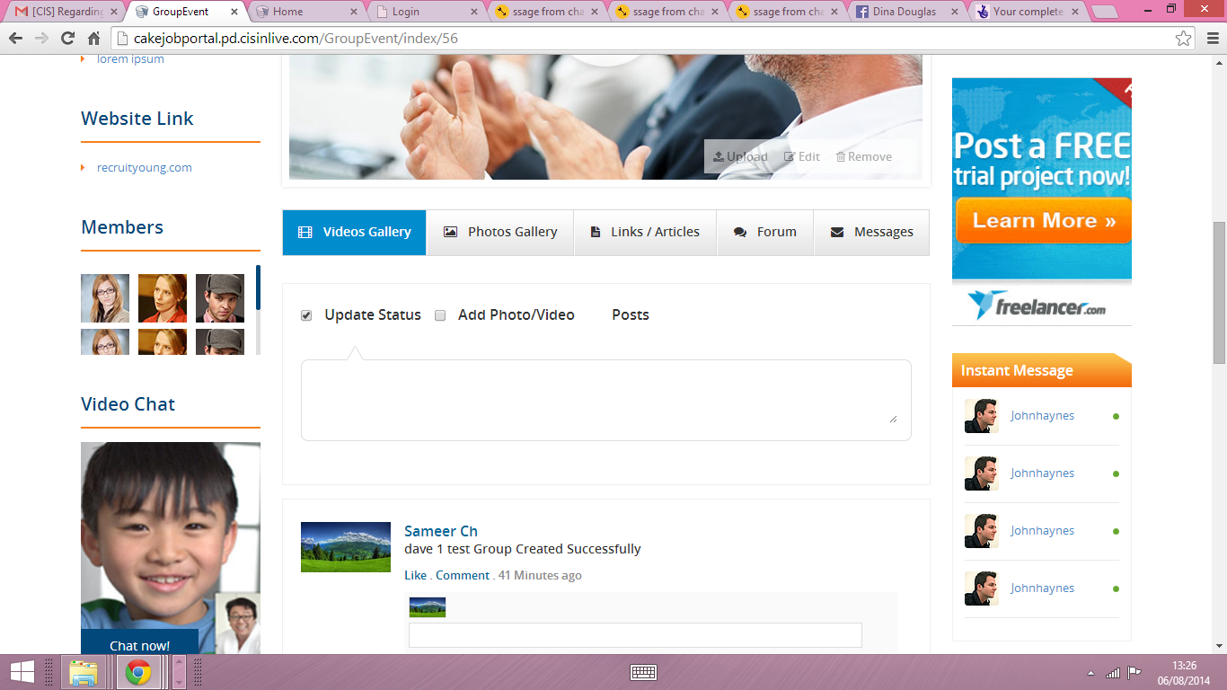
Once the group is create a post says dave 1 test group create successful coming from Sameer ch maybe change to Recruit Young with the logo image for the picture. Thanks.
3) Personal Email message inbox, to check online and a copy or notice is sent to their email address that they signed up with. Available to site members only
Status: Done
URL: http://cakejobportal.pd.cisinlive.com/mail/index/inbox
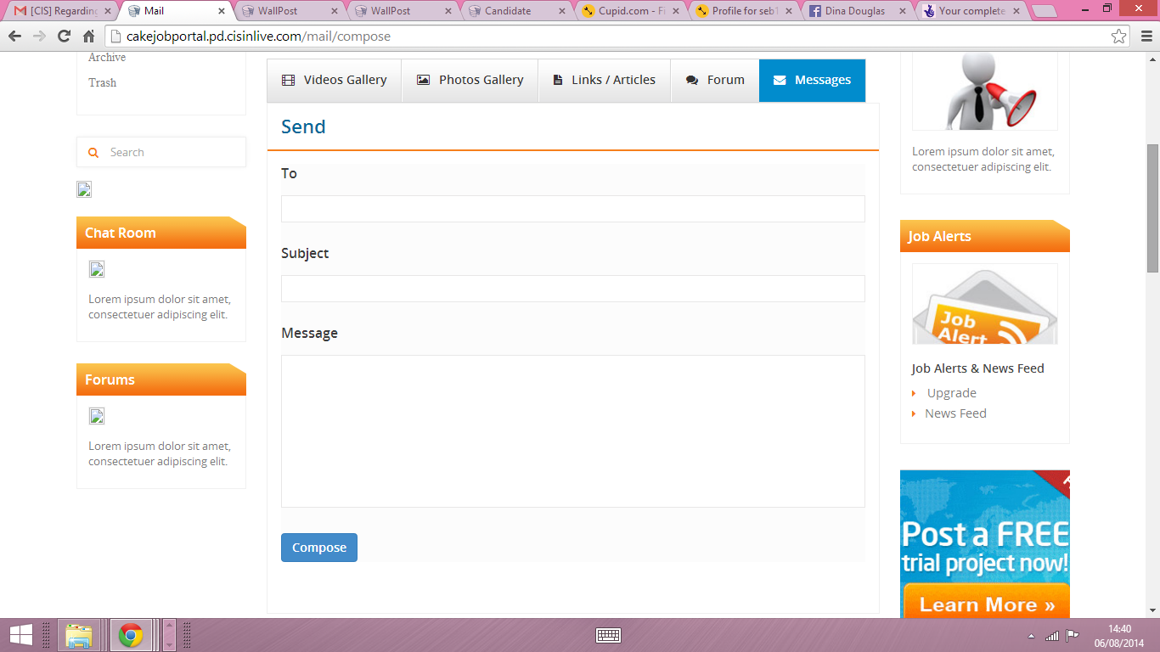
The send button should be on after the message section and the compose word on top. Please switch.
The ”TO” section text box does not work because the users require a personal email address to send messages to.
4) Area on the candidate or employer profile for anyone to leave a character reference or job reference
Status: Done
URL: http://cakejobportal.pd.cisinlive.com/candidate/candidate_profile
URL: http://cakejobportal.pd.cisinlive.com/employer/profile 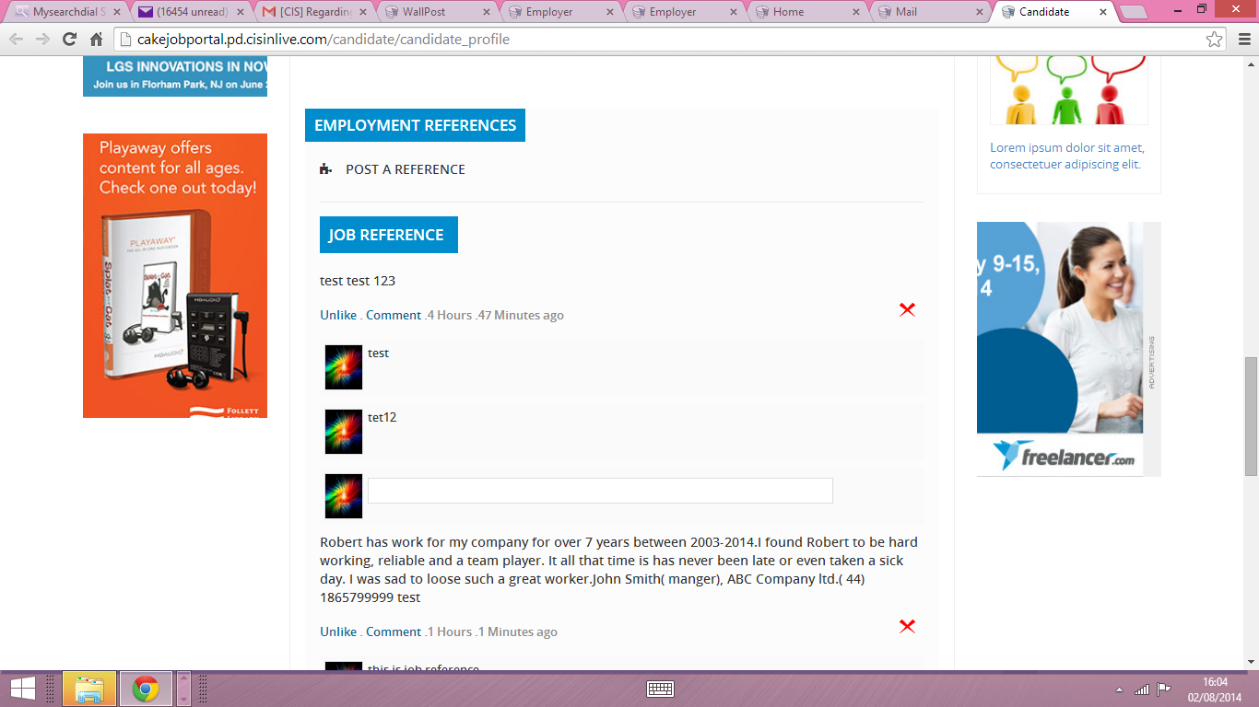
The post a reference – does not work, here it should allow the user to post details for a reference.
I am not able to post anything under character reference section (this feature did not work).
5) Rolling news feed of Updates for candidate and or business network. (Wall Post)
Status: Done
URL: http://cakejobportal.pd.cisinlive.com/WallPost
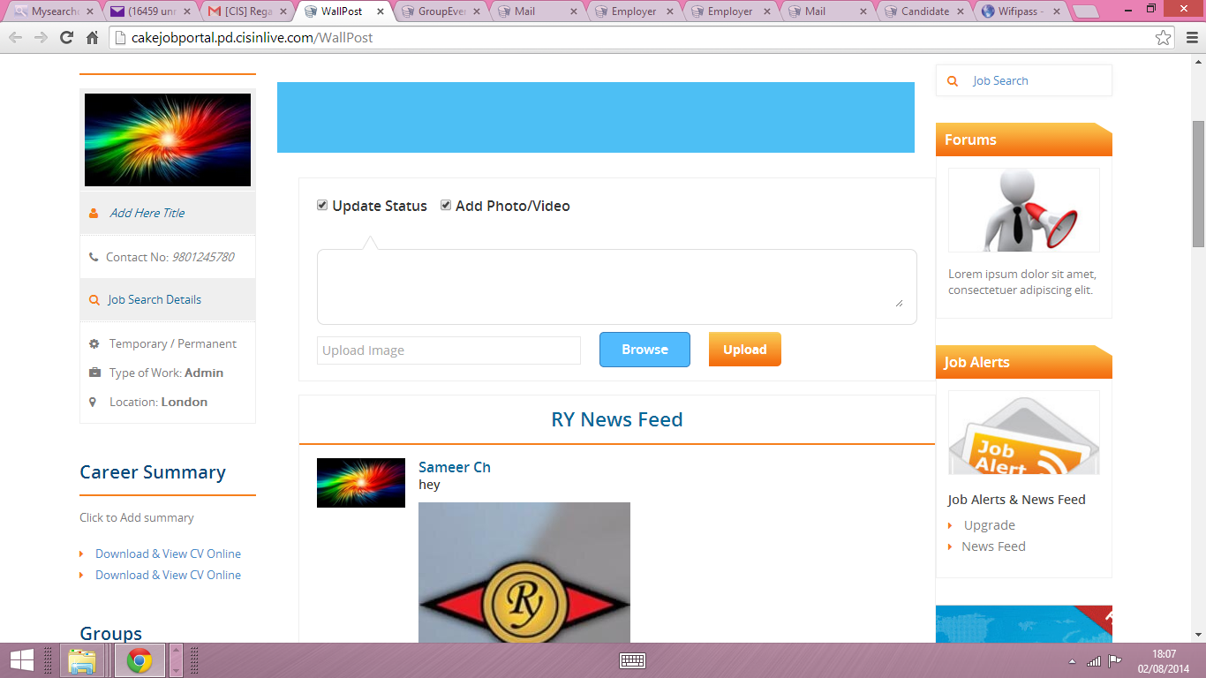
The RY NEWS FEED would look better in the blue banner on top of the page. Also the rolling news feed should also be in located on the side in place of the image under job alerts once you click on it would link to the user’s wall post. Otherwise the user has no way to get to their wall post.
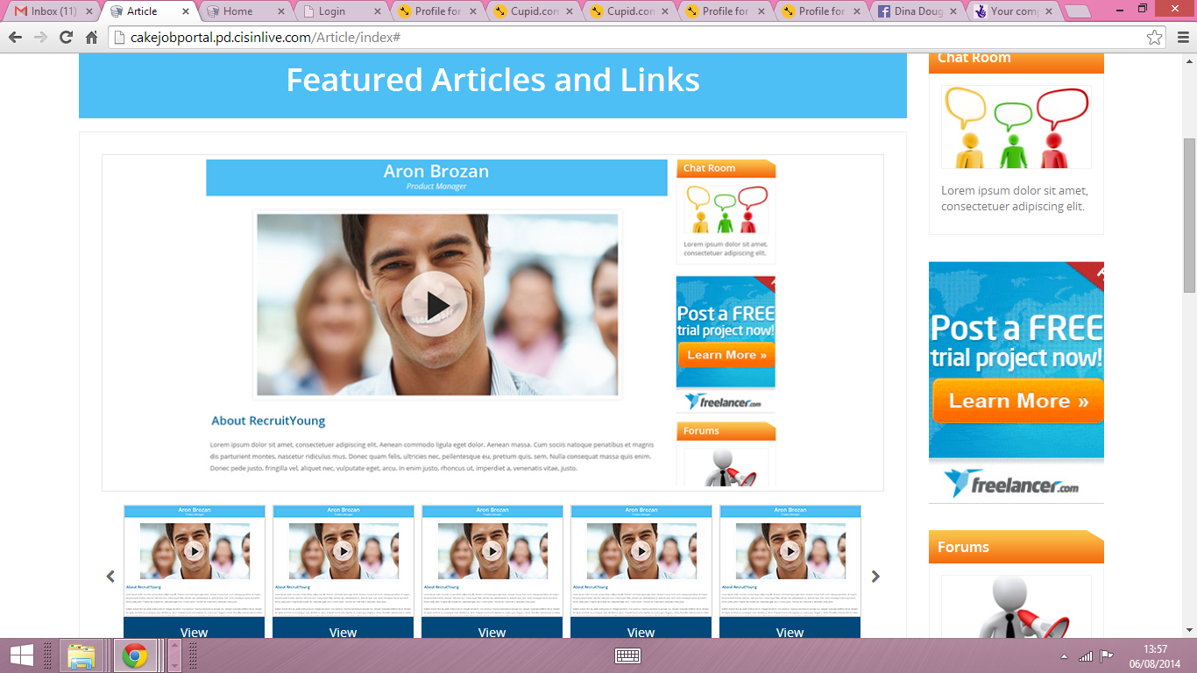
The feature articles and links – This does not work.
- the article should be linked to the standard template to allow user to edit it.
- As soon a article is created it goes into the article gallery section
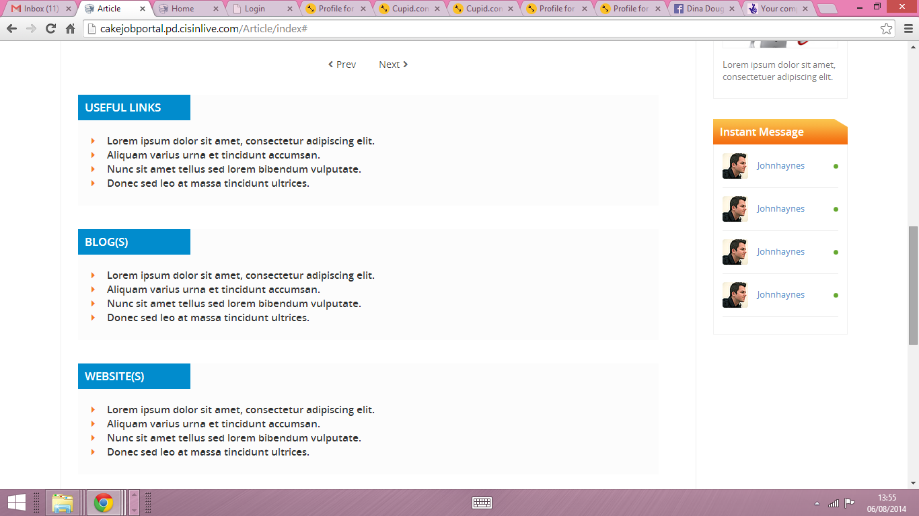
- Useful links tabs section does not work – should have an empty text box so they can edit or delete text.
- Same for Blog(s) and website(s)

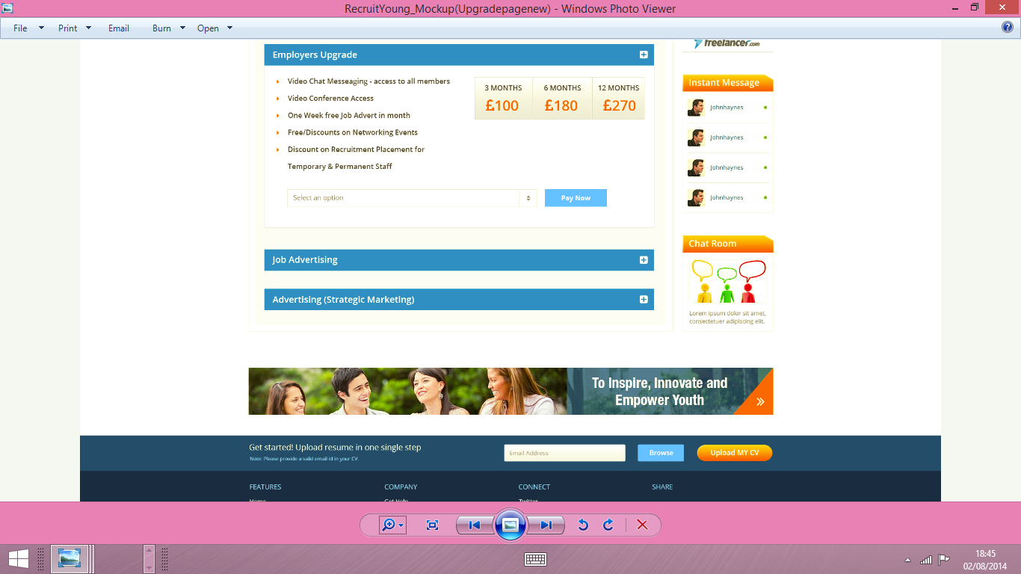
6) Also under the upgrade section or link; where is the mention of the cost for the job adverts this is missing for the employer . There is only mention of the employers upgrade, advertise (strategic marketing) but no job advert costing.
a) Please see the below mock up- this how it should look and what is required to be there.
Comment: Here if new user is signup then Employer/Candidate Upgrade is seems when users click upgrade link after that he/she paid and make member then it seems job advert costing too as mentioned in attach file(Screenshot from 2014-08-04 20:33:21.png). Please check it and if you need anything then send me details ? – yes the job adverting is a different costing from membership upgrade and strategic marketing- difference things are offered for each.

